# ADO 15771 BBR UWP- Issue in Business Category field when changed from Surplus to Admitted

Steps-

Create a quote in AP

Recall the quote in UWP

Change the Business Category from Surplus to Admitted

Actual Result-

After changing the business category from surplus to admitted, the field business category is getting hidden in the Risk Information section.

It is also prohibiting to proceed further.

Expected Result-

It should display the field even after changing the field value from surplus to admitted.

Screenshots-

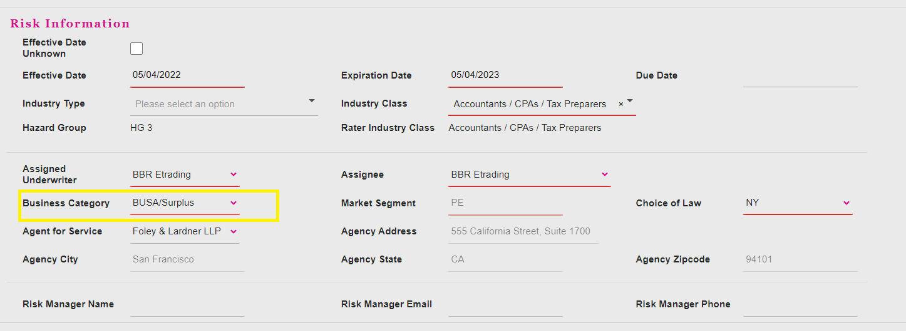

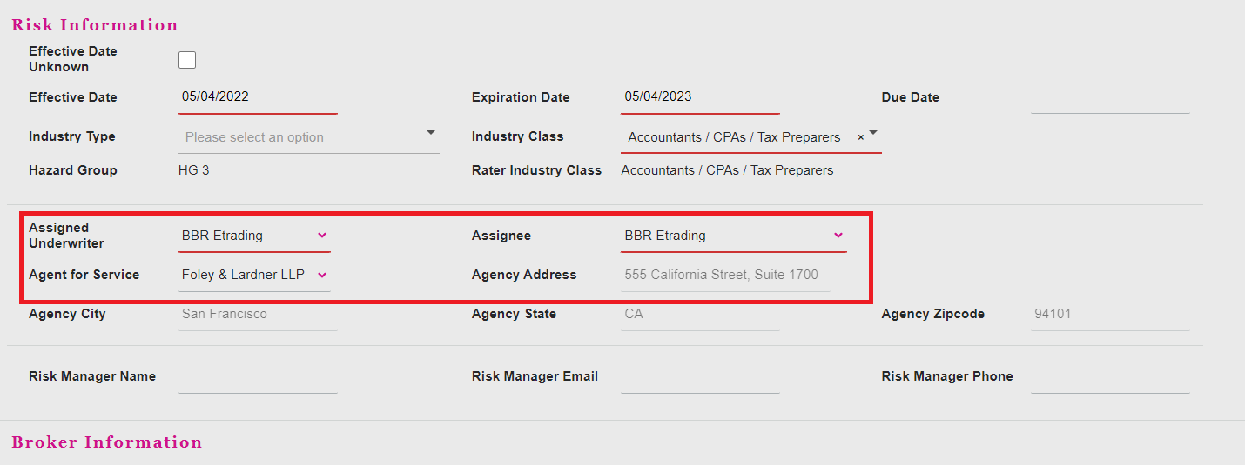

Test Results:

Created a quote in AP

Open the quote in UWP

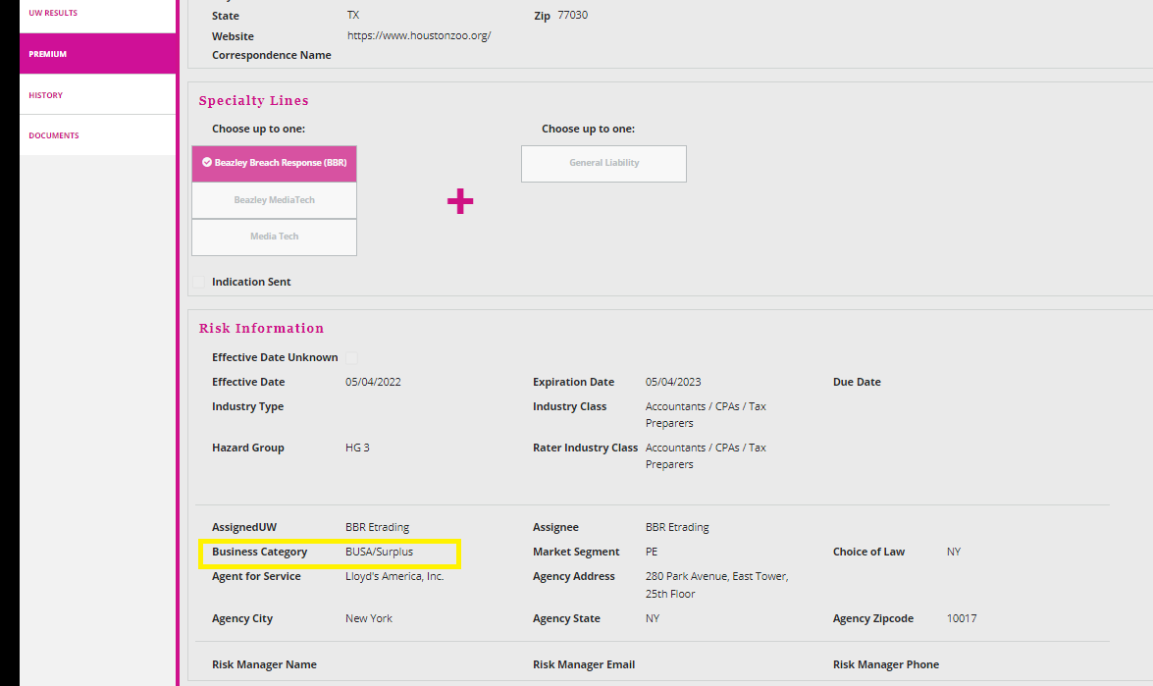

Change the business class from Surplus to Admitted

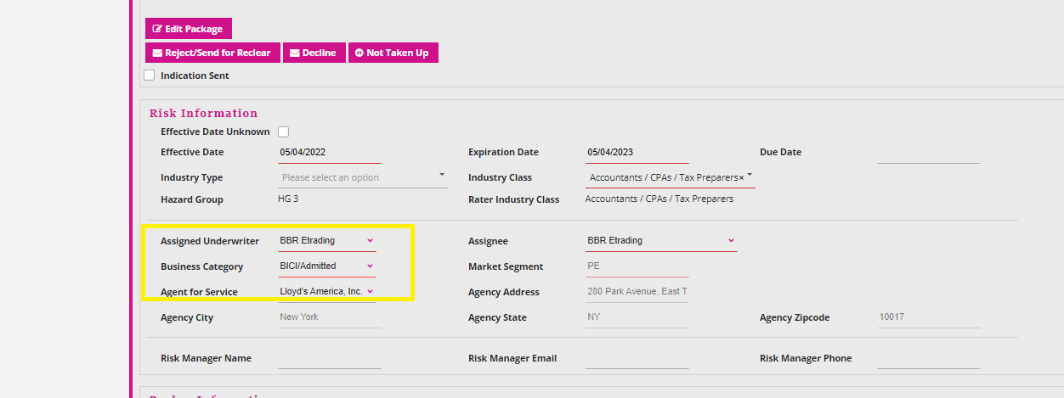

Expected result:

The business category field did not disappear once the value was changed from Surplus to Admitted.